Introduction

The goal of this project is to help students gain an in-depth understanding and practice of the basic rendering techniques of 3dmodeling. A planetary system was chosen to be constructed as this system allows for a concise demonstration of the techniques.

Design and features

The design features of this project are as follows. Use studio.h,b,unist.h,gl.h,glu.h,glut.h and freeglut.h for the library. Use the method of drawing spheres to create the planets. Use the method of getting random values to fill the colour of the planets. Use gl's functions to render the planets with the ability to select colours and set positions, which incluing the process of creating geometry, transformations, viewing/projection, lighting and materials, texture mapping. Use an if command to add moons to the planets and nest functions such as speed and volume adjustment in advance. Use pushmatrix and popmatrix to implement a hierarchy of planets.

Detailed explanation can be seen in the comments of the source code.

Instruction

Keyboard operations via the keyboard function.

Press Aa key: add planets or moons

Press Rr keyboard: delete all planets

Press Pp key: pause to start

Press Qq: exit

Press Dd: delete the selected planet or satellite

Press +-: change speed

Press ><: change radius

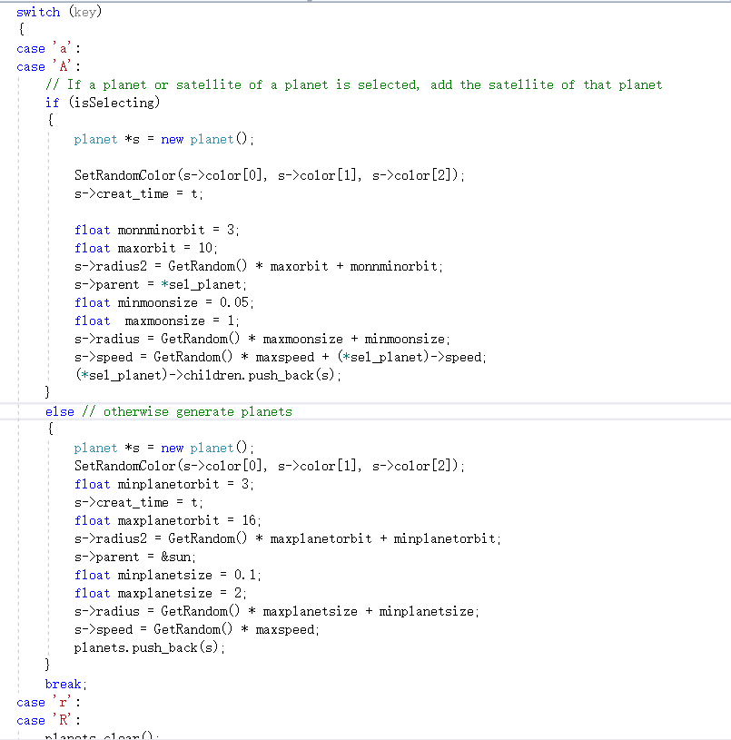



Screenshot

Here are several screenshots illustrating movement of the star system



The sun overshadows other planets

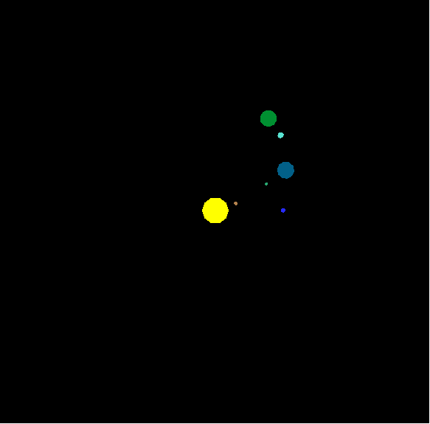

Celestial motion observed from above.

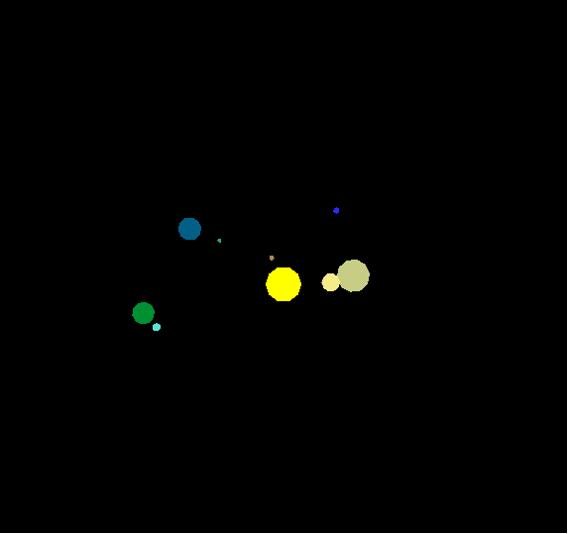

Celestial motion observed from above.

Celestial motion observed from above, double star over the sun

Celestial motion observed from above, double star over the sun.

Conclusion

Th planetary system demonstrates each of the 3dmodeling techniques required by the material in the context of achieving the required functionality. This includes but is not limited to geometry implementation, hierarchical modelling, transformations, projection, lighting, texture mapping, animating and interactions supportance. In the future, the mastery of these techniques will play an important role in the study of computer graphics.